Base-AudioTM

FOR IMMEDIATE RELEASE Contact: Joe O’Connor
December 15, 2015 800-381-1794
Email: Sales@Base-Audio.com

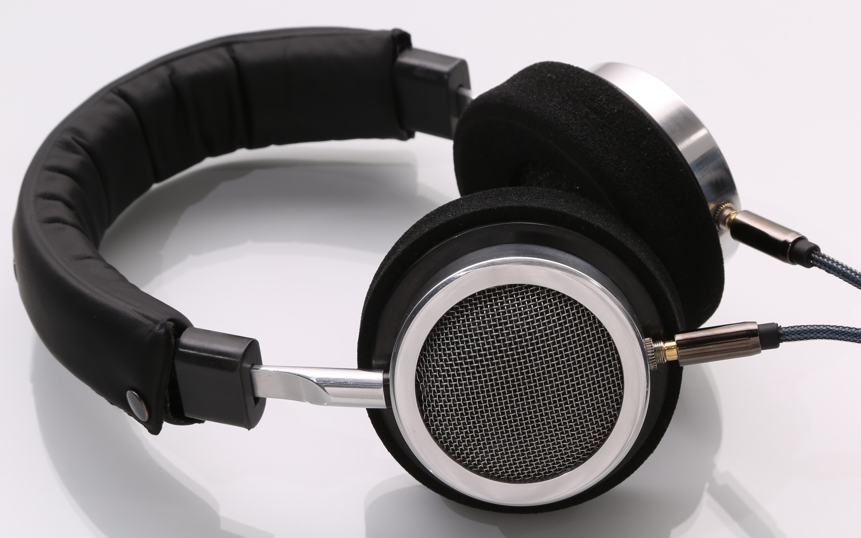

Base Audio to Unveil Latest Innovative Headphone Technology in Las Vegas

Scottsdale based company debuts at
Consumer Electronics Show

Scottsdale, Arizona - What better place for a new electronics company to showcase its innovative, handcrafted, high fidelity headphones than the Consumer Electronics Show (CES) in Las Vegas, Nevada next month.

The Scottsdale start-up earned a coveted spot in Eureka Park at CES this year where all eyes will be on their innovative design and high quality products. The Reflex Series Headphones are one of only a few audio companies manufacturing their product in the United States.

“We are proud to hand-make our high quality audio products right here in America”, said Base Audio Creator, Joe O’Connor. “At a time when many companies are moving their manufacturing operations overseas, we want to provide reliable, audio products right here at home.”

The unmatched, high fidelity sound and quality craftsmanship sets Base Audio apart from its competition. The Reflex Series was specifically engineered for portable devices such as, laptops, tablets, and smart phones, but produces exceptional sound quality with traditional amplifiers and receivers as well.

The well- crafted construction includes driver enclosures made from high- strength aluminum to ensure durability and solid sound reproduction. The soft headband pad covers a formulated spring steel headband for years of continuous use, endurance and comfort.

“The engineering and design of the open system headphone was created to capture the true high fidelity sound while minimizing the “in your head music” typically associated with closed systems,” said O’Connor. “Comfort factors were also considered during the design. The unique size and fit adjustments provide positive resistance without discomfort which allows the headphones to rest comfortably on your head while laying down or reclining without pressure.”

Base Audio’s Reflex Series Headphones will be available for market March 1, 2016. The headphones are expected to retail for $249.00.

About Base Audio
Founded in 2014, Base Audio is based in Scottsdale, Arizona and manufactures their line of audio products exclusively in the U.S. Base Audio was created by Joe O’Connor and Pat Eberly. The creators of Base Audio have a combined 40 years of development and manufacturing experience between them.

For more information on Base Audio visit www.base-audio.com or call
800-381-1794.

###

